Table S1. Overview of the ecoacoustic intensity metrics applied in this study to characterize ambient sound. Statistical evaluation was conducted in R (v4.3.0)[1]. TOL = one-third-octave level.
Metric | Statistical evaluation and illustration | Computation | Setting | References
Power spectral density level  (PSD; dB re 1 µPa Hz⁻¹) | Seasonal mean, median, and percentiles (1%, 5%, 25%, 75%, 95%, and 99%) | MANTA | Time interval: 1 min; Frequency resolution: hybrid millidecade | [2-4]; widely applied
Spectral probability density  (SPD) | Seasonal empirical probability distribution of PSDLs across frequencies | Derived from MANTA product | Histogram bin width for probability density: 0.1 | [5, 6]; widely applied
Sound pressure level  (SPL; dB re 1 µPa²):  - Broadband (10-3428 Hz)  - 20 Hz TOL band (FS)  - 25 Hz TOL band (WS)  - 63 Hz TOL band  - 125 Hz TOL band  - 250 Hz TOL band  - 500 Hz TOL band | Seasonal mean, median, min, max, and percentiles (25%, 75%) | Derived from MANTA product | Time interval: 1 min  Frequency resolution: broadband (10-3,428 Hz) and TOL bands | [7, 8]; widely and increasingly applied

Table S2. Summary of the ecoacoustic diversity metrics selected to characterize the spectro-temporal intensity variability and the respective settings applied to compute these metrics over the broadband frequency range (10-3,428 Hz) and for each 10 min *.wav file. These metrics were computed using R (v4.3.0)[1], and the R-packages TuneR [9], Seewave [10], and Soundecology [11].
Metric | Short description | Intended soundscape characteristics to describe in this study | R-package and Setting | Reference
ACI  (acoustic complexity index) | Intensity variation across time. | Temporal heterogeneity | Seewave,  Hanning-window; window lengths = 512 points; overlap = 50%; number of windows = 10 | [12]
AEI  (acoustic evenness index) | Heterogeneity of intensity variation across frequency bands (Gini coefficient) and above a set power threshold. | Spectral heterogeneity | Soundecology,  Size of frequency bands = 10 Hz; dB threshold = -50 dB | [13]
ADI  (acoustic diversity index) | Evenness of intensity variation across frequency bands (Shannon’s Diversity Index) and above a set power threshold. | Spectral uniformity | Soundecology,  Size of frequency bands = 10 Hz; dB threshold = -50 dB | [13]
HI  (total entropy) | Evenness of intensity variation across time and frequency above a set power threshold. (Shannon evenness of the amplitude envelop). | Spectral and temporal uniformity | Seewave,  Window lengths = 512 points, Hilbert amplitude envelop; smoothing = NULL | [14]
BI (bioacoustic index) | Area under the spectrum curve between two frequency limits. | Spectral heterogeneity | Soundecology,  FFT (Fast Fourier Transformation) window size = 512 points | [15]

Table S3. Monthly (seasonal) and annual mean, median, percentile range, and minimum and maximum SPL (dB re 1 µPa) for the Fram Strait (FS) station. IQR= inter quartile range.
Frequency band | Boreal summer  (Aug. 2016) | Boreal autumn  (Nov. 2016) | Boreal winter  (Feb. 2017) | Boreal spring  (May. 2017) | Annual
 | Mean (± standard deviation)
10-3428 Hz | 112.0 (±4.7) | 113.3 (±5.3) | 114.2 (±6.1) | 109.0 (±3.9) | 112.5 (±5.2)
20 Hz | 105.4 (±5.6) | 100.5 (±4.2) | 101.2 (±5.1) | 98.0 (±4.4) | 102.2 (±5)
63 Hz | 97.1 (±3.6) | 96.1 (±3.6) | 95.2 (±3.9) | 97.0 (±3.6) | 96.4 (±3.7)
125 Hz | 93.5 (±3.3) | 94.6 (±3.3) | 95.2 (±4.3) | 94.0 (±3.3) | 94.3 (±3.7)
250 Hz | 89.3 (±3.5) | 93.0 (±3.3) | 93.6 (±4.0) | 92.0 (±3.8) | 92.2 (±4)
500 Hz | 87.9 (±3.8) | 91.3 (±3.7) | 92.2 (±4.4) | 90.7 (±4.1) | 90.7 (±4.3)
 | Median
10-3428 Hz | 106.5 | 109.3 | 110.4 | 106.5 | 107.6
20 Hz | 97.5 | 96.9 | 95.0 | 95.8 | 96.3
63 Hz | 94.6 | 94.5 | 93.4 | 95.8 | 94.6
125 Hz | 90.7 | 93.3 | 93.3 | 91.8 | 92.1
250 Hz | 87.9 | 91.8 | 92.3 | 89.5 | 90.1
500 Hz | 87.4 | 89.8 | 91.3 | 88.7 | 88.7
 | Percentile range 25 - 75% (IQR)
10-3428 Hz | 104.5 - 109.5 (5) | 105.4 - 113.0 (7.6) | 105.3 - 114.8 (9.5) | 103.9 - 109.0 (5.1) | 104.7-111.4 (6.7)
20 Hz | 94.6 - 100.9 (6.3) | 94.4 - 100.1 (5.7) | 92.9 - 97.5 (4.6) | 91.9 - 98.5 (6.6) | 93.5- 99.4 (5.9)
63 Hz | 92.8 - 97.1 (4.3) | 92.2 - 97.0 (4.8) | 90.2 - 96.7 (6.5) | 92.7 - 98.2 (5.5) | 92.1-97.4 (5.3)
125 Hz | 89.1 - 92.5 (3.4) | 91.2 - 95.4 (4.2) | 89.3 - 96.7 (7.4) | 89.8 - 94.2 (4.4) | 89.8-94.7 (4.9)
250 Hz | 85.4 - 90.2 (4.8) | 89.3 - 94.2 (4.9) | 88.6 - 95.2 (6.6) | 87.0 - 92.0 (5.0) | 87.4-92.9 (5.5)
500 Hz | 84.4 - 89.2 (4.8) | 86.8 - 92.4 (5.6) | 87.3 - 93.9 (6.6) | 86.0 - 90.7 (4.7) | 86.0-91.6 (5.6)
 | Min. – Max. (range width)
10-3428 Hz | 93.8-134.6 (40.8) | 97.7-132.4 (34.7) | 98.3-133.2 (34.9) | 95.2-138.7 (43.5) | 93.8-138.7 (44.9)
20 Hz | 81.4-131.0 (49.6) | 89.7-124.1 (34.4) | 86.8-128.0 (41.2) | 81.4-132.8 (51.4) | 81.4-132.8 (51.4)
63 Hz | 83.5-117.0 (33.5) | 84.1-108.7 (24.6) | 85.1-105.1 (20.) | 85.6-114.4 (28.8) | 83.5-117.0 (33.5)
125 Hz | 80.7-114.6 (33.9) | 84.3-100.7 (16.4) | 84.9-102.6 (17.7) | 84.1-119.6 (35.5) | 80.7-119.6 (38.9)
250 Hz | 77.8-105.4 (27.6) | 83.6-99.5 (15.9) | 83.7-99.8 (16.1) | 80.4-119.2 (38.8) | 77.8-119.2 (41.4)
500 Hz | 75.0-100.6 (25.6) | 80.9-98.5 (17.6) | 79.9-98.9 (19.0) | 76.5-117.1 (40.6) | 75.0-117.1 (42.1)

Table S4. Monthly (seasonal) and annual mean, median, percentile range, and minimum and maximum SPL (dB re 1 µPa) for the Weddell Sea (WS) station. IQR= inter quartile range.
Frequency band | Austral autumn  (May 2017) | Austral winter  (Aug. 2017) | Austral spring  (Nov 2017) | Austral summer  (Feb. 2018) | Annual
 | Mean
10-3428 Hz | 108.0 (±1) | 105.3 (±1.7) | 102.8 (±1.8) | 112.8 (±1.2) | 108.7 (±4.1)
25 Hz | 102.8 (±0.9) | 96.7 (±1.2) | 94.9 (±1.5) | 108.7 (±1.4) | 103.9 (±5.6)
63 Hz | 91.1 (±1.8) | 89.7 (±2.2) | 86.3 (±1.5) | 100.0 (±1.3) | 94.8 (±3.4)
125 Hz | 89.4 (±1.9) | 95.7 (±2.3) | 90.8 (±2.4) | 94.9 (±1.7) | 93.5 (±3.4)
250 Hz | 81.8 (±3.4) | 89.2 (±3.2) | 86.2 (±3.1) | 91.9 (±2.4) | 88.6 (±5.1)
500 Hz | 80.4 (±4.9) | 83.8 (±4.7) | 81.3 (±3.8) | 91.2 (±4.3) | 86.4 (±6.4)
 | Median
10-3428 Hz | 104.6 | 107.5 | 101.7 | 112.4 | 106.4
25 Hz | 96.2 | 102.7 | 94.2 | 108.3 | 99.0
63 Hz | 88.9 | 90.8 | 85.6 | 99.6 | 90.0
125 Hz | 95.2 | 89.1 | 90.5 | 94.1 | 92.2
250 Hz | 87.8 | 79.7 | 84.2 | 90.7 | 86.1
500 Hz | 80.3 | 76.1 | 78.7 | 89.6 | 80.2
 | Percentile range 25 - 75% (IQR)
10-3428 Hz | 103.6-105.7 (2.1) | 107.0-107.9 (0.9) | 100.9-103.0 (2.1) | 111.8-113.3 (1.5) | 103.4 - 108.9 (5.5)
25 Hz | 95.6-97.1 (1.5) | 102.2-103.1 (0.9) | 93.4-95.2 (1.8) | 107.5-109.3 (1.8) | 95.5 - 103.7 (8.2)
63 Hz | 87.5-90.4 (2.9) | 89.6-91.7 (2.1) | 84.9-86.6 (1.7) | 98.9-100.4 (1.5) | 86.9 - 93.5 (6.6)
125 Hz | 93.6-96.5 (2.9) | 87.8-90.4 (2.6) | 88.2-91.7 (3.5) | 93.4-95.3 (1.9) | 89.7 - 94.6 (4.9)
250 Hz | 85.8-89.7 (3.9) | 77.7-81.9 (4.2) | 82.5-86.3 (3.8) | 89.4-92.4 (3.0) | 82.0 - 89.7 (7.7)
500 Hz | 77.4-83.6 (6.2) | 73.0-79.4 (6.4) | 76.6-81.4 (4.8) | 86.4-92.1 (5.7) | 76.5 - 85.8 (9.3)
 | Min. – Max. (range width)
10-3428 Hz | 100.4-133.8 (33.4) | 101.0-142.2 (41.2) | 98.3-131.7 (33.4) | 108.3-127.8 (19.5) | 98.3 - 142.2 (43.9)
25 Hz | 88.3-124.2 (35.9) | 95.3-129.2 (33.9) | 88.0-120.6 (32.6) | 98.0-121.3 (23.3) | 88.0 - 129.2 (41.2)
63 Hz | 82.5-108.4 (25.9) | 82.6-113.3 (30.7) | 80.9-105.3 (24.4) | 91.7-116.6 (24.9) | 80.9 - 116.6 (35.7)
125 Hz | 87.9-109.6 (21.7) | 80.8-111.1 (30.3) | 83.0-107.1 (24.1) | 89.2-114.4 (25.2) | 80.8 - 111.4 (30.6)
250 Hz | 77.0-109.3 (32.3) | 69.6-109.7 (40.1) | 75.8-107.2 (31.4) | 84.8-106.1 (21.3) | 69.6 - 109.7 (40.1)
500 Hz | 68.4-107.3 (38.9) | 66.3-108.0 (41.7) | 68.8-110.6 (41.8) | 77.2-106.5 (29.3) | 66.3 - 110.6 (44.3)

Table S5. Statistical results for the linear regression models to assess the influence of wind speed (m/s) and the sea ice concentration (SIC; %), and differences between seasons, on the sound pressure levels of defined frequency bands for the Fram Strait (FS) station and the Weddell Sea (WS) station. The wind speed, SIC, and season were applied as fixed terms on the hourly means (2879 and 2877 observations in total for the FS station and the WS stations, respectively) of the SPLs, we also included an interaction term of wind speed and SIC. For the broadband SPL and the 63, and 125 Hz TOL bands at the FS station a generalized linear gamma regression model using a log-link was applied. A general linear regression model was fitted for the 250 and 500 Hz TOL band with a log-link and an identity-link, respectively, for the FS station. General linear models were fitted for the broadband SPL, 63, 250, and 500 Hz TOL band with an identity-link and for the 125 Hz with a log-link at the WS station. At the FS station the seasons correspond to the boreal summer (2016-Aug), spring (2017-Feb), autumn (2017-Nov), and winter (2017-Feb) and at the WS station to austral summer (2018-Feb), autumn (2017-May), winter (2017-Aug), and spring (2017-Nov). Statistical evaluation was conducted in R (v4.3.3)[1]
Generalized model equation: y = β + β₁×WindSpeed + β₂×SIC + β₃×Autumn + β₄×Winter + β₅×Spring + β₆×WindSpeed:SIC
 | Fram Strait |  |  |  |  | Weddell Sea
Broadband SPL
Predictors | Estimates | std. Error | Conf. Int (95%) |  | p | Estimates | std. Error | Conf. Int (95%) |  | p
(Intercept) | 105.62 | 0.26 | 105.11 – 106.13 |  | <0.001 | 111.26 | 0.14 | 110.99 – 111.54 |  | <0.001
WindSpeed | 1.00 | 0.00 | 1.00 – 1.00 |  | <0.001 | 0.19 | 0.02 | 0.15 – 0.22 |  | <0.001
SIC | 1.00 | 0.00 | 1.00 – 1.00 |  | <0.001 | 0.03 | 0.01 | 0.02 – 0.04 |  | <0.001
Autumn | 1.02 | 0.00 | 1.01 – 1.02 |  | <0.001 | -7.44 | 0.70 | -8.80 – -6.07 |  | <0.001
Winter | 1.02 | 0.00 | 1.02 – 1.03 |  | <0.001 | -10.20 | 0.70 | -11.56 – -8.83 |  | <0.001
Spring | 0.97 | 0.00 | 0.97 – 0.98 |  | <0.001 | -12.56 | 0.67 | -13.88 – -11.24 |  | <0.001
WindSpeed×SIC | 1.00 | 0.00 | 1.00 – 1.00 |  | 0.020 | -0.00 | 0.00 | -0.00 – -0.00 |  | <0.001
 | Pseudo R² = 0.153 |  |  |  |  | R² = 0.885
63 Hz TOL
(Intercept) | 92.36 | 0.18 | 92.01 – 92.70 |  | <0.001 | 98.87 | 0.16 | 98.56 – 99.17 |  | <0.001
WindSpeed | 1.00 | 0.00 | 1.00 – 1.00 |  | <0.001 | 0.14 | 0.02 | 0.10 – 0.18 |  | <0.001
SIC | 1.01 | 0.00 | 1.00 – 1.01 |  | <0.001 | -0.01 | 0.01 | -0.03 – 0.00 |  | 0.148
Autumn | 0.99 | 0.00 | 0.98 – 0.99 |  | <0.001 | -8.10 | 0.79 | -9.64 – -6.55 |  | <0.001
Winter | 0.97 | 0.00 | 0.97 – 0.97 |  | <0.001 | -9.75 | 0.79 | -11.30 – -8.21 |  | <0.001
Spring | 0.98 | 0.00 | 0.98 – 0.99 |  | <0.001 | -12.75 | 0.76 | -14.24 – -11.26 |  | <0.001
WindSpeed×SIC | 1.00 | 0.00 | 1.00 – 1.00 |  | <0.001 | -0.00 | 0.00 | -0.00 – 0.00 |  | 0.937
 | Pseudo R²= 0.220 |  |  |  |  | R² = 0.915
125 Hz TOL
(Intercept) | 87.62 | 0.16 | 87.31 – 87.94 |  | <0.001 | 4.53 | 0.00 | 4.52 – 4.53 |  | <0.001
WindSpeed | 1.01 | 0.00 | 1.01 – 1.01 |  | <0.001 | 0.00 | 0.00 | 0.00 – 0.00 |  | <0.001
SIC | 1.00 | 0.00 | 1.00 – 1.00 |  | 0.012 | -0.00 | 0.00 | -0.00 – -0.00 |  | <0.001
Autumn | 1.02 | 0.00 | 1.01 – 1.02 |  | <0.001 | 0.01 | 0.01 | -0.01 – 0.03 |  | 0.407
Winter | 1.01 | 0.00 | 1.00 – 1.01 |  | <0.001 | 0.08 | 0.01 | 0.06 – 0.10 |  | <0.001
Spring | 1.00 | 0.00 | 1.00 – 1.01 |  | 0.482 | 0.02 | 0.01 | 0.00 – 0.04 |  | 0.049
WindSpeed×SIC | 1.00 | 0.00 | 1.00 – 1.00 |  | 0.767 | -0.00 | 0.00 | -0.00 – -0.00 |  | <0.001
 | Pseudo R² = 0.314 |  |  |  |  | R² = 0.689
250 Hz TOL
(Intercept) | 83.36 | 0.14 | 83.09 – 83.64 |  | <0.001 | 86.50 | 0.27 | 85.97 – 87.02 |  | <0.001
WindSpeed | 1.01 | 0.00 | 1.01 – 1.01 |  | <0.001 | 0.63 | 0.03 | 0.56 – 0.69 |  | <0.001
SIC | 1.00 | 0.00 | 1.00 – 1.00 |  | <0.001 | 0.07 | 0.01 | 0.05 – 0.10 |  | <0.001
Autumn | 1.04 | 0.00 | 1.03 – 1.04 |  | <0.001 | -15.06 | 1.35 | -17.71 – -12.41 |  | <0.001
Winter | 1.03 | 0.00 | 1.02 – 1.03 |  | <0.001 | -7.28 | 1.35 | -9.92 – -4.63 |  | <0.001
Spring | 1.02 | 0.00 | 1.02 – 1.03 |  | <0.001 | -9.85 | 1.30 | -12.40 – -7.30 |  | <0.001
WindSpeed×SIC | 1.00 | 0.00 | 1.00 – 1.00 |  | <0.001 | -0.00 | 0.00 | -0.01 – -0.00 |  | <0.001
 | R² = 0.538 |  |  |  |  | R² = 0.713
500 Hz TOL
(Intercept) | 80.06 | 0.13 | 79.81 – 80.31 |  | <0.001 | 79.93 | 0.37 | 79.21 – 80.66 |  | <0.001
WindSpeed | 0.90 | 0.01 | 0.87 – 0.93 |  | <0.001 | 1.25 | 0.05 | 1.16 – 1.33 |  | <0.001
SIC | -0.26 | 0.03 | -0.32 – -0.19 |  | <0.001 | 0.09 | 0.02 | 0.05 – 0.13 |  | <0.001
Autumn | 2.04 | 0.12 | 1.81 – 2.28 |  | <0.001 | -15.17 | 1.85 | -18.80 – -11.54 |  | <0.001
Winter | 1.50 | 0.13 | 1.26 – 1.75 |  | <0.001 | -11.12 | 1.85 | -14.75 – -7.49 |  | <0.001
Spring | 1.91 | 0.16 | 1.59 – 2.22 |  | <0.001 | -12.05 | 1.79 | -15.56 – -8.55 |  | <0.001
WindSpeed×SIC | 0.03 | 0.00 | 0.02 – 0.03 |  | <0.001 | -0.01 | 0.00 | -0.01 – -0.01 |  | <0.001
 | R² = 0.709 |  |  |  |  | R² = 0.659

Table S6. Statistical results for the linear regression models to assess the influence of wind speed (m/s) and the sea ice concentration (SIC; %), and differences between seasons, on the diversity metrics for the Fram Strait (FS) station and the Weddell Sea (WS) station. The wind speed, SIC, and season were applied as fixed terms on the hourly means (2874 observations in total for each recording site) of the diversity metrics, we also included an interaction term of wind speed and SIC. A beta-regression was applied for the AEI and the HI. For the AEI a log-link and for the HI a logit-link was applied. A generalized linear gamma regression with a log-link was applied on the ACI and ADI for both regions, and the BI for the FS station. A general linear model was fitted for the BI for the WS station. Additionally, the ADI was inverse transformed to follow a gamma distribution. At the FS station the seasons correspond to the boreal summer (2016-Aug), spring (2017-Feb), autumn (2017-Nov), and winter (2017-Feb) and at the WS station to austral summer (2018-Feb), autumn (2017-May), winter (2017-Aug), and spring (2017-Nov). Statistical evaluation was conducted in R (v4.3.3)[1]
Generalized model equation: y = β + β₁×WindSpeed + β₂×SIC + β₃×Autumn + β₄×Winter + β₅×Spring + β₆×WindSpeed:SIC
 | Fram Strait |  |  |  |  | Weddell Sea
ACI
Predictors | Estimates | std. Error | Conf. Int (95%) |  | p | Estimates | std. Error | Conf. Int (95%) |  | p
(Intercept) | 1524.64 | 2.78 | 1519.21 – 1530.09 |  | <0.001 | 1474.67 | 1.42 | 1471.89 – 1477.46 |  | <0.001
WindSpeed | 1.00 | 0.00 | 1.00 – 1.00 |  | <0.001 | 1.00 | 0.00 | 1.00 – 1.00 |  | 0.378
SIC | 1.00 | 0.00 | 1.00 – 1.00 |  | 0.435 | 1.00 | 0.00 | 1.00 – 1.00 |  | 0.353
Autumn | 1.01 | 0.00 | 1.00 – 1.01 |  | 0.002 | 1.00 | 0.00 | 0.99 – 1.01 |  | 0.485
Winter | 0.99 | 0.00 | 0.99 – 0.99 |  | <0.001 | 1.00 | 0.00 | 0.99 – 1.01 |  | 0.630
Spring | 0.98 | 0.00 | 0.98 – 0.99 |  | <0.001 | 0.98 | 0.00 | 0.97 – 0.99 |  | <0.001
WindSpeed×SIC | 1.00 | 0.00 | 1.00 – 1.00 |  | 0.051 | 1.00 | 0.00 | 1.00 – 1.00 |  | <0.001
Pseudo R² | 0.132 |  |  |  |  | 0.406
AEI
(Intercept) | 0.41 | 0.02 | 0.38 – 0.45 |  | <0.001 | 0.98 | 0.03 | 0.91 – 1.04 |  | 0.463
WindSpeed | 0.87 | 0.00 | 0.86 – 0.88 |  | <0.001 | 0.84 | 0.00 | 0.83 – 0.85 |  | <0.001
SIC | 1.06 | 0.01 | 1.04 – 1.08 |  | <0.001 | 0.99 | 0.00 | 0.98 – 0.99 |  | <0.001
Autumn | 0.88 | 0.03 | 0.81 – 0.95 |  | 0.001 | 2.95 | 0.55 | 2.05 – 4.26 |  | <0.001
Winter | 0.81 | 0.03 | 0.75 – 0.88 |  | <0.001 | 1.89 | 0.35 | 1.31 – 2.73 |  | 0.001
Spring | 0.58 | 0.03 | 0.52 – 0.65 |  | <0.001 | 1.19 | 0.21 | 0.83 – 1.69 |  | 0.343
WindSpeed × SIC | 0.99 | 0.00 | 0.99 – 1.00 |  | <0.001 | 1.00 | 0.00 | 1.00 – 1.00 |  | <0.001
Pseudo R² | 0.464 |  |  |  |  | 0.504
ADI
(Intercept) | 5.54 | 0.01 | 5.57 – 5.52 |  | <0.001 | 4.99 | 0.03 | 5.05 – 4.93 |  | <0.001
WindSpeed | 1.00 | 0.00 | 1.00 – 1.00 |  | <0.001 | 1.01 | 0.00 | 1.02 – 1.01 |  | <0.001
SIC | 1.00 | 0.00 | 1.00 – 1.00 |  | 0.197 | 1.00 | 0.00 | 1.00 – 1.00 |  | 0.001
Autumn | 1.00 | 0.00 | 1.00 – 1.00 |  | 0.950 | 0.87 | 0.03 | 0.92 – 0.82 |  | <0.001
Winter | 1.01 | 0.00 | 1.01 – 1.00 |  | 0.003 | 0.95 | 0.03 | 1.01 – 0.90 |  | 0.128
Spring | 1.02 | 0.00 | 1.02 – 1.01 |  | <0.001 | 0.99 | 0.03 | 1.05 – 0.93 |  | 0.642
WindSpeed×SIC | 1.00 | 0.00 | 1.00 – 1.00 |  | 0.431 | 1.00 | 0.00 | 1.00 – 1.00 |  | <0.001
Pseudo R² | 0.121 |  |  |  |  | 0.444
HI
(Intercept) | 0.77 | 0.02 | 0.76 – 0.78 |  | <0.001 | 0.65 | 0.02 | 0.64 – 0.67 |  | <0.001
WindSpeed | 0.53 | 0.00 | 0.52 – 0.53 |  | <0.001 | 0.54 | 0.00 | 0.53 – 0.54 |  | <0.001
SIC | 0.48 | 0.00 | 0.48 – 0.49 |  | <0.001 | 0.50 | 0.00 | 0.50 – 0.50 |  | <0.001
Autumn | 0.50 | 0.01 | 0.48 – 0.51 |  | 0.454 | 0.33 | 0.05 | 0.27 – 0.40 |  | <0.001
Winter | 0.51 | 0.01 | 0.50 – 0.53 |  | 0.025 | 0.40 | 0.06 | 0.33 – 0.47 |  | 0.004
Spring | 0.59 | 0.02 | 0.58 – 0.61 |  | <0.001 | 0.49 | 0.07 | 0.42 – 0.56 |  | 0.788
WindSpeed × SIC | 0.50 | 0.00 | 0.50 – 0.50 |  | <0.001 | 0.50 | 0.00 | 0.50 – 0.50 |  | <0.001
Pseudo R² | 0.444 |  |  |  |  | 0.602
BI
(Intercept) | 124.39 | 0.93 | 122.59 – 126.22 |  | <0.001 | 240.28 | 2.40 | 235.58 – 244.98 |  | <0.001
WindSpeed | 0.97 | 0.00 | 0.97 – 0.98 |  | <0.001 | -2.91 | 0.29 | -3.49 – -2.34 |  | <0.001
SIC | 1.01 | 0.00 | 1.00 – 1.01 |  | 0.001 | -0.29 | 0.13 | -0.53 – -0.04 |  | 0.022
Autumn | 1.08 | 0.01 | 1.06 – 1.09 |  | <0.001 | 8.10 | 12.05 | -15.51 – 31.71 |  | 0.501
Winter | 1.04 | 0.01 | 1.03 – 1.06 |  | <0.001 | 43.02 | 12.05 | 19.40 – 66.64 |  | <0.001
Spring | 1.04 | 0.01 | 1.02 – 1.06 |  | <0.001 | 19.33 | 11.62 | -3.45 – 42.11 |  | 0.096
WindSpeed×SIC | 1.00 | 0.00 | 1.00 – 1.00 |  | 0.001 | 0.01 | 0.00 | -0.00 – 0.01 |  | 0.147
Pseudo R² | 0.393 |  |  |  |  | 0.284

Table S7. Loadings of the used hourly means of ten ecoacoustic metrics (broadband SPL, 63, 125, 250, 500 Hz TOL band SPL, ACI, AEI, ADI, HI, BI) on the first two principal components. The highest positive or negative loadings are highlighted in bold.
Ecoacoustic metric | PC1 | PC2
500 Hz | 0.435 | -0.090
250 Hz | 0.400 | -0.180
HI | 0.390 | 0.308
AEI | -0.380 | -0.350
ADI | 0.340 | 0.349
63 Hz | 0.282 | -0.415
BI | -0.266 | -0.146
125 Hz | 0.244 | -0.382
Broadband | 0.172 | -0.517
ACI | -0.003 | -0.112

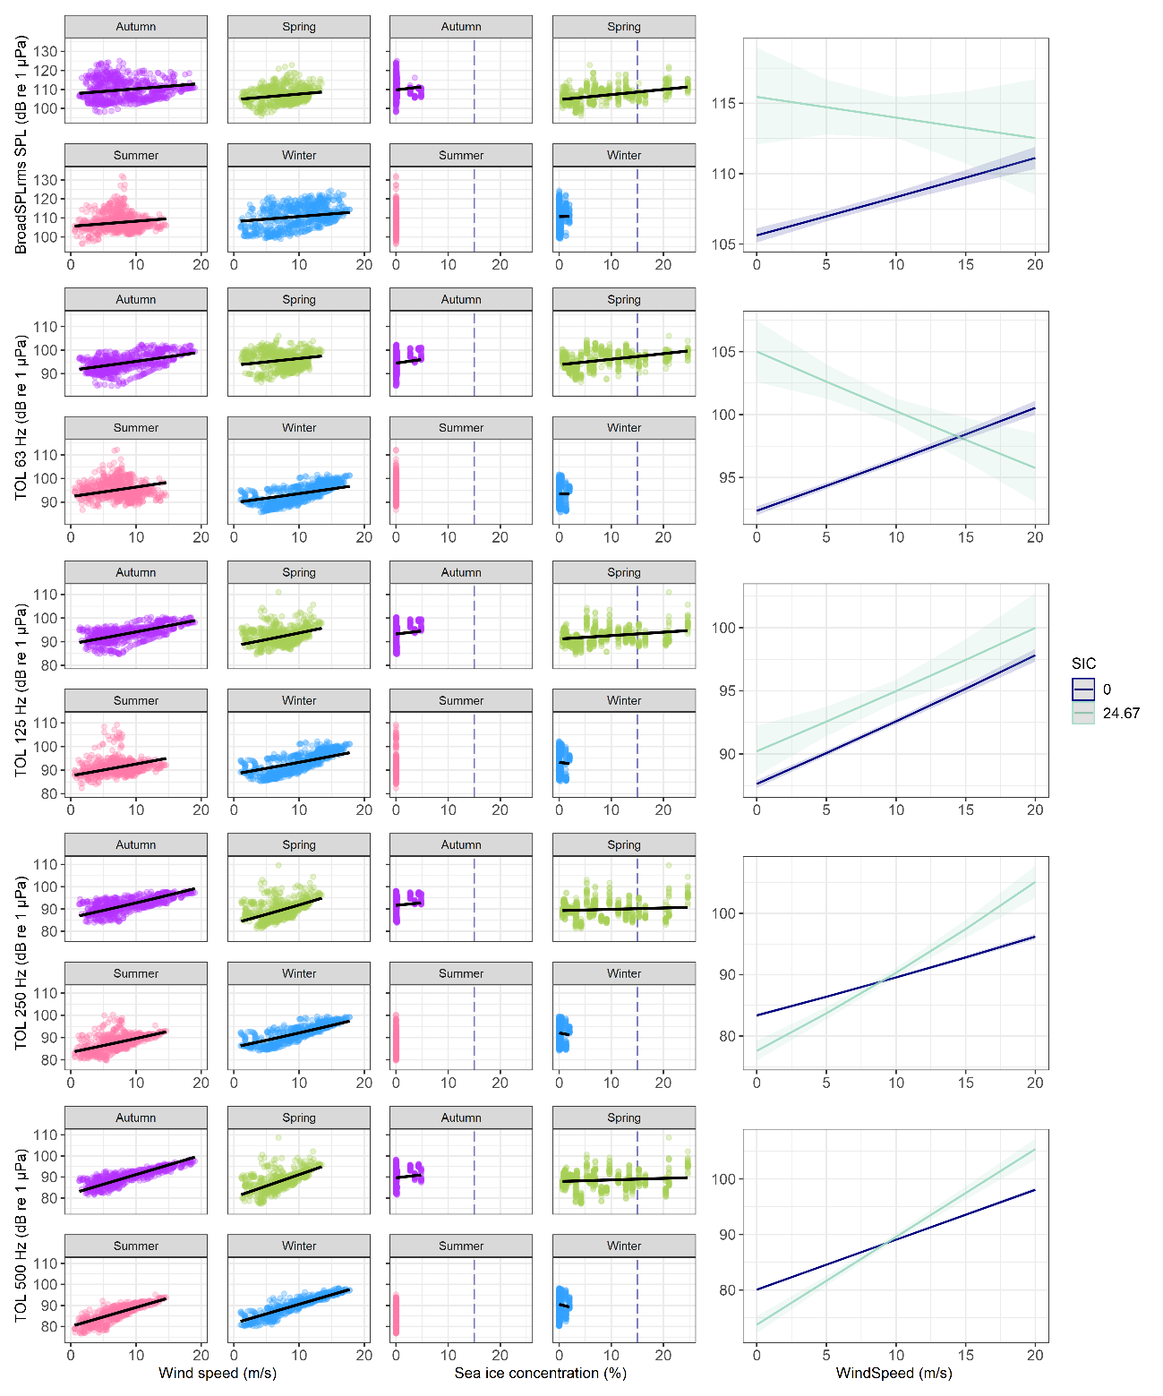
Figure S1. General and generalized linear regression models (black line) for the SPLs measured at the Fram Strait (FS) station corresponding to Table S5. The wind speed (m/s), and sea ice concentration (SIC, %), and season were applied as fixed terms on the hourly means (2758 observations in total; points show true data) of the SPLs, we also included an interaction term of wind speed and SIC. For the broadband SPL and the 63, and 125 Hz 1/3-octave level (TOL) bands a generalized linear gamma regression model using a log-link was applied. A general linear regression model was fitted for the 250 and 500 Hz TOL band with a log-link and an identity-link, respectively. The plots in the right panel show the interaction prediction of the marginal mean effect size of wind speed and SIC on the SPLs. The seasons correspond to boreal summer (2016-Aug, pink), boreal spring (2017-Feb, green), boreal autumn (2017-Nov, purple), and boreal winter (2017-Feb, blue). The dashed vertical blue line in the middle panel indicates the SIC threshold for open water conditions (SIC ≤15%).
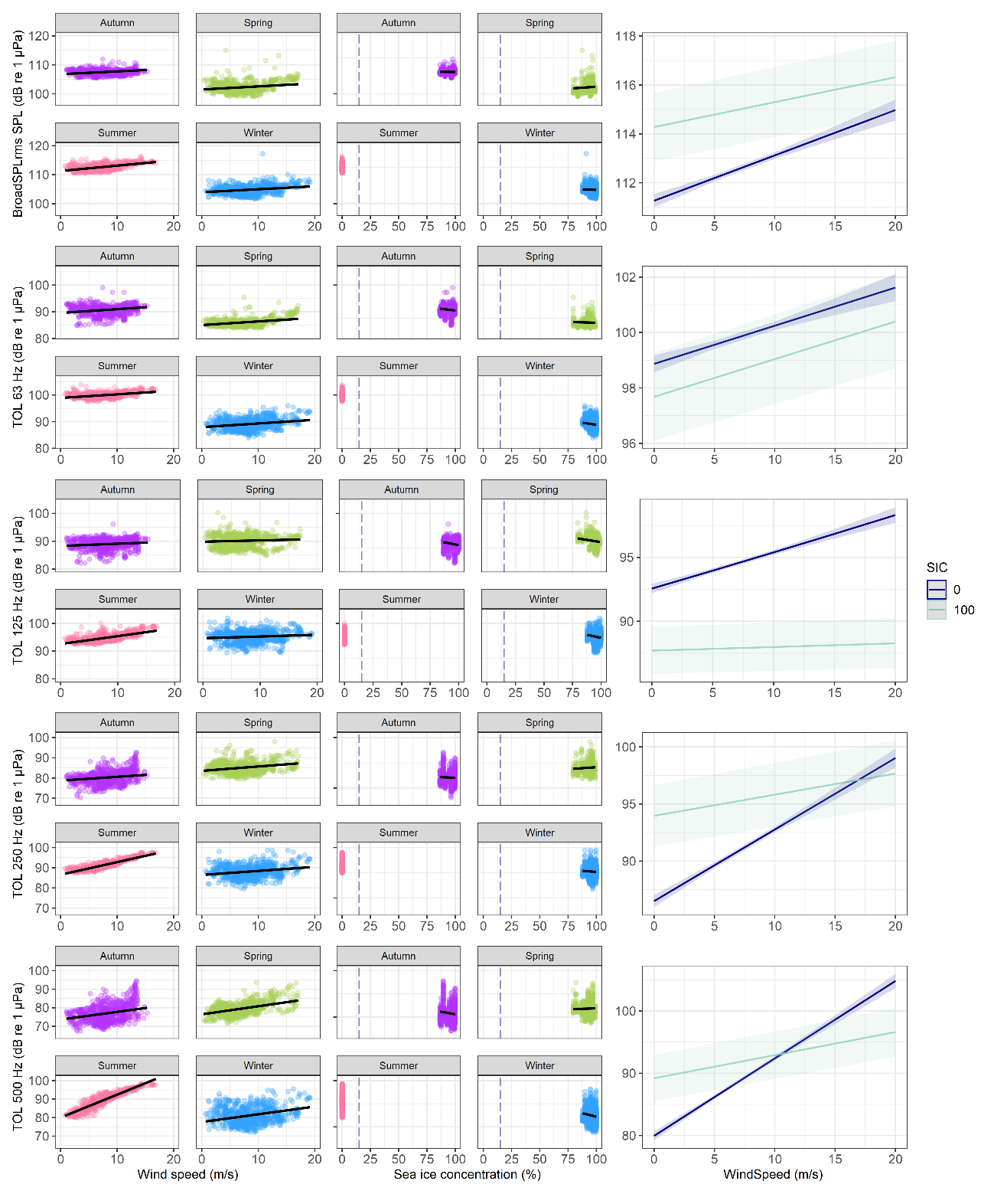
Figure S2. General linear regression models (black line) for the SPLs measured at the Weddell Sea (WS) station corresponding to Table S5. The wind speed (m/s), and sea ice concentration (SIC, %), and season were applied as fixed terms on the hourly means (2758 observations in total; points show true data) of the SPLs, we also included an interaction term of wind speed and SIC. General linear models were fitted for the broadband SPL, 63, 250, and 500 Hz TOL band with an identity-link and for the 125 Hz with a log-link. The plots in the right panel show the interaction prediction of the marginal mean effect size of wind speed and SIC on the SPLs. The seasons correspond to austral summer (2018-Feb, pink), austral autumn (2017-May, purple), austral winter (2017-Aug, blue), and austral spring (2016-Nov, green). The dashed vertical blue line in the middle panel indicates the SIC threshold for open water conditions (SIC ≤15%).

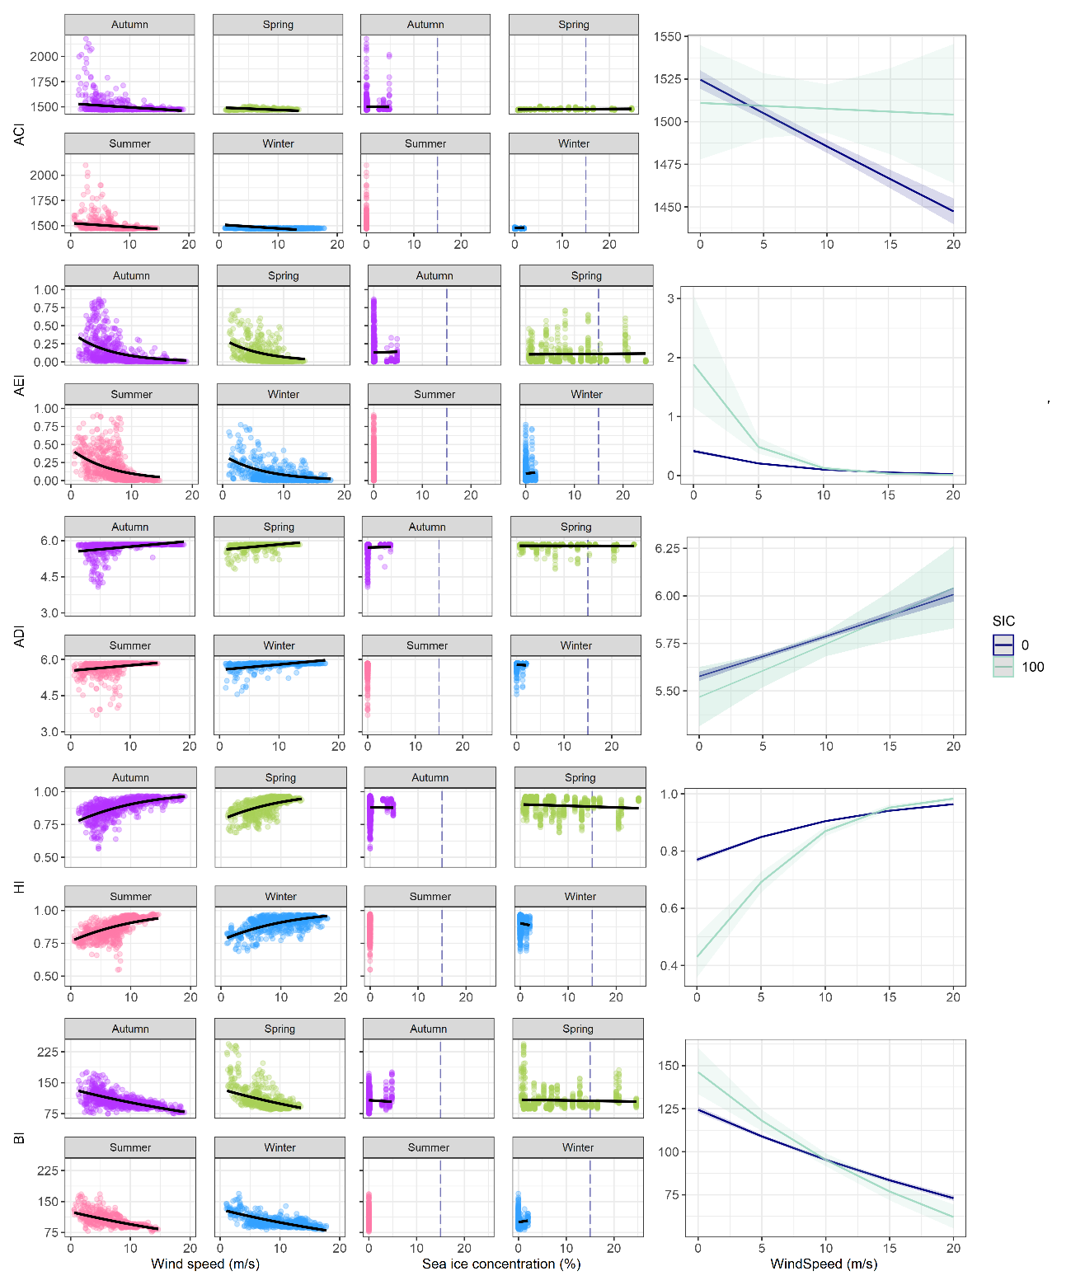
Figure S3. Generalized and beta linear regression models (black line) for the ecoacoustic diversity metrics measured at the Fram Strait (FS) station corresponding to Table S6. The wind speed (m/s), and sea ice concentration (SIC, %), and season were applied as fixed terms on the hourly means (2760 observations in total; points show true data) of the diversity metrics, we also included an interaction term of wind speed and SIC. A beta-regression was applied for the AEI and the HI. For the AEI a log-link and for the HI a logit-link was applied. A generalized linear gamma regression with a log-link was applied on the ACI, ADI, and BI. Additionally, the ADI was inverse transformed to follow a gamma distribution. The plots in the right panel show the interaction prediction of the marginal mean effect size of wind speed and SIC on the SPLs. The seasons correspond to boreal summer (2016-Aug, pink), boreal spring (2017-Feb, green), boreal autumn (2017-Nov, purple), and boreal winter (2017-Feb, blue). The dashed vertical blue line in the middle panel indicates the SIC threshold for open water conditions (SIC ≤15%).
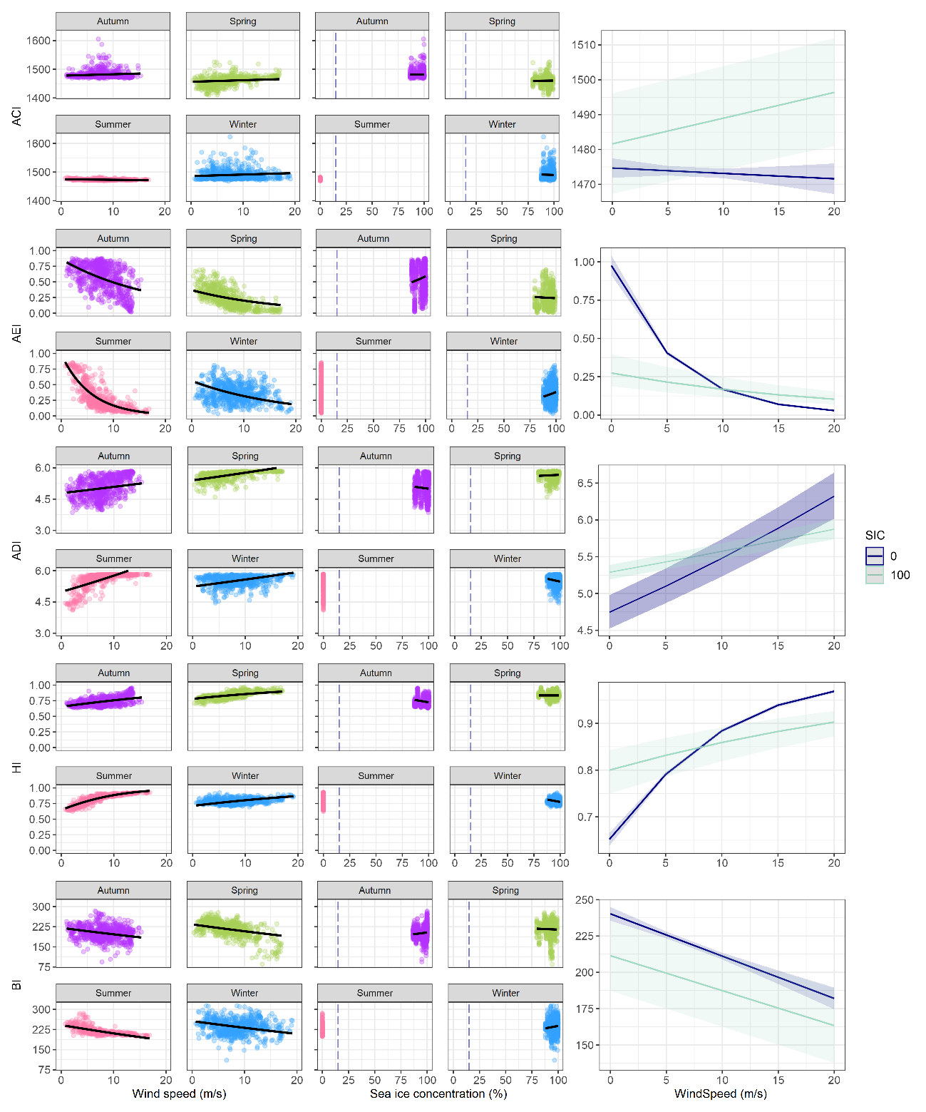
Figure S4. Generalized and beta linear regression models (black line) for the ecoacoustic diversity metrics measured at the Weddell Sea (WS) station corresponding to Table S6. The wind speed (m/s), and sea ice concentration (SIC, %), and season were applied as fixed terms on the hourly means (2760 observations in total; points show true data) of the diversity metrics, we also included an interaction term of wind speed and SIC. A beta-regression was applied for the AEI and the HI. For the AEI a log-link and for the HI a logit-link was applied. A generalized linear gamma regression with a log-link was applied on the ACI and ADI. A general linear model was fitted for the BI. Additionally, the ADI was inverse transformed to follow a gamma distribution. The plots in the right panel show the interaction prediction of the marginal mean effect size of wind speed and SIC on the SPLs. The seasons correspond to austral summer (2018-Feb, pink), austral autumn (2017-May, purple), austral winter (2017-Aug, blue), and austral spring (2016-Nov, green). The dashed vertical blue line in the middle panel indicates the SIC threshold for open water conditions (SIC ≤15%).

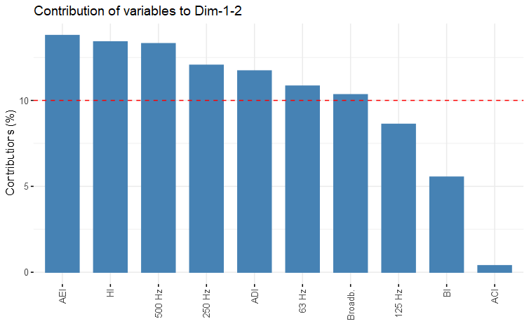
Figure S5. The contributions of the ten ecoacoustic metrics explaining 70% of the variance in the first two principal components. A principal component analysis (PCA) for feature selection was applied using the hourly mean of ten ecoacoustic metrics (broadband SPL, 63 Hz, 125 Hz, 250 Hz, 500 Hz TOL band, ACI, AEI, ADI, HI, BI). The contributions with more than 10% were regarded as the metrics with the highest explanatory power in describing overall soundscape characteristics and influencing cluster forming.

References

1 R Core Team. 2023 R: A language and environment for statistical computing. . R Foundation for Statistical Computing. (https://www.R-project.org/, last acessed 11.12.2023)
2 Martin, S. B., Gaudet, B. J., Klinck, H., Dugan, P. J., Miksis-Olds, J. L., Mellinger, D. K., Mann, D. A., Boebel, O., Wilson, C. C., Ponirakis, D. W., Moors-Murphy, H. 2021 Hybrid millidecade spectra: A practical format for exchange of long-term ambient sound data. JASA Express Letters. 1, 011203-011203. (10.1121/10.0003324)
3 Martin, S. B., Gaudet, B. J., Klinck, H., Dugan, P. J., Miksis-Olds, J. L., Mellinger, D. K., Mann, D. A., Boebel, O., Wilson, C. C., Ponirakis, D. W., Moors-Murphy, H. 2021 Erratum: Hybrid millidecade spectra: A practical format for exchange of long-term ambient sound data [JASA Express Lett. 1(1), 011203 (2021)]. JASA Express Lett. 1, 081201. (10.1121/10.0005818)
4 Miksis-Olds, J. L., Dugan, P. J., Martin, S. B., Klinck, H., Mellinger, D. K., Mann, D. A., Ponirakis, D. W., Boebel, O. 2021 Ocean Sound Analysis Software for Making Ambient Noise Trends Accessible (MANTA). Front. Mar. Sci. 8, 703650. (10.3389/fmars.2021.703650)
5 Merchant, N. D., Barton, T. R., Thompson, P. M., Pirotta, E., Dakin, D. T., Dorocicz, J. 2013 Spectral probability density as a tool for ambient noise analysis. J. Acoust. Soc. Am. 133, EL262-267. (10.1121/1.4794934)
6 Merchant, N. D., Fristrup, K. M., Johnson, M. P., Tyack, P. L., Witt, M. J., Blondel, P., Parks, S. E. 2015 Measuring acoustic habitats. Methods Ecol. Evol. 6, 257-265. (10.1111/2041-210X.12330)
7 MSFD. 2017 Commission Decision (EU) 2017/848 of 17 May 2017 laying down criteria and methodological standards on good environmental status of marine waters and specifications and standardised methods for monitoring and assessment, and repealing Decision 2010/477/EU. Official Journal of the European Communities. L125, 43-74. (http://data.europa.eu/eli/dec/2017/848/oj; last accessed 11.12.2023)
8 Merchant, N. D., Brookes, K. L., Faulkner, R. C., Bicknell, A. W., Godley, B. J., Witt, M. J. 2016 Underwater noise levels in UK waters. Sci. Rep. 6, 36942. (10.1038/srep36942)
9 Ligges, U., Krey, S., Mersmann, O., Schnackenberg, S. 2023 R package "tuneR": Analysis of Music and Speech. Version 1.4.6, (https://CRAN.R-project.org/package=tuneR, last acessed 11.12.2023)
10 Sueur, J., Aubin, T., Simonis, C. 2008 Seewave: a free modular tool for sound analysis and synthesis. Bioacoustics. 18, 213-226. (10.1080/09524622.2008.9753600)
11 Villanueva-Rivera, L. J., Pijanowski, B. C. 2018 R package "soundecology": Soundscape Ecology. Version 1.3.3, (https://CRAN.R-project.org/package=soundecology, last acessed 11.12.2023)
12 Pieretti, N., Farina, A., Morri, D. 2011 A new methodology to infer the singing activity of an avian community: The Acoustic Complexity Index (ACI). Ecol. Indic. 11, 868-873. (10.1016/j.ecolind.2010.11.005)
13 Villanueva-Rivera, L. J., Pijanowski, B. C., Doucette, J., Pekin, B. 2011 A primer of acoustic analysis for landscape ecologists. Landsc. Ecol. 26, 1233-1246. (10.1007/s10980-011-9636-9)
14 Sueur, J., Pavoine, S., Hamerlynck, O., Duvail, S. 2008 Rapid acoustic survey for biodiversity appraisal. PloS one. 3, e4065. (10.1371/journal.pone.0004065)
15 Boelman, N. T., Asner, G. P., Hart, P. J., Martin, R. E. 2007 Multi-trophic invasion resistance in Hawaii: bioacoustics, field surveys, and airborne remote sensing. Ecol. Appl. 17, 2137-2144. (10.1890/07-0004.1)

